**58. Add Dependencies**

--- **note** - In this lecture, you learn how to configure and use chart dependencies to do that, go to the firstchart.

--- **scenario** – our application needs mysql to server the traffic. Here I will create a dependency in application chart and it will automatically install mysql when we install our app.

--- Open the chart.yaml go to the end of it and add the dependency section.

--- tree

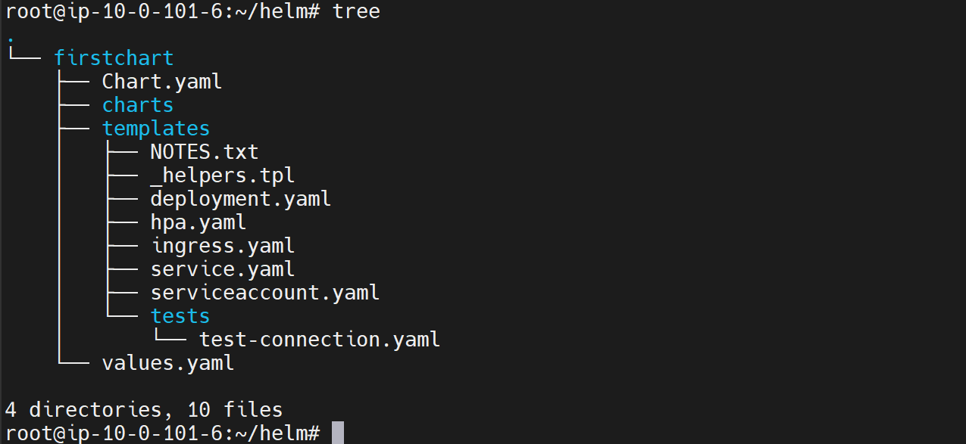

--- vi chart.yaml

apiVersion: v2

name: firstchart

description: A Helm chart for Kubernetes

# A chart can be either an 'application' or a 'library' chart.

#

# Application charts are a collection of templates that can be packaged into versioned archives

# to be deployed.

#

# Library charts provide useful utilities or functions for the chart developer. They're included as

# a dependency of application charts to inject those utilities and functions into the rendering

# pipeline. Library charts do not define any templates and therefore cannot be deployed.

type: application

# This is the chart version. This version number should be incremented each time you make changes

# to the chart and its templates, including the app version.

# Versions are expected to follow Semantic Versioning (https://semver.org/)

version: 0.1.0

# This is the version number of the application being deployed. This version number should be

# incremented each time you make changes to the application. Versions are not expected to

# follow Semantic Versioning. They should reflect the version the application is using.

# It is recommended to use it with quotes.

appVersion: "1.16.0"I

**dependencies:**

**- name: mysql # the name of the dependency, mysql is the chart name.**

**version: "~8.8.0-0" # you can use any version here.**

**repository: "https://charts.bitnami.com/bitnami" # this repository is where this chart pulled form. provide the complete url of the repository**

--- **important** - The next step is to update the dependency so that this dependency will be pulled to the charts folder.

**# Update dependency for our chart.**

--- helm dependency update firstchart

# List the structure of firstchart

--- tree

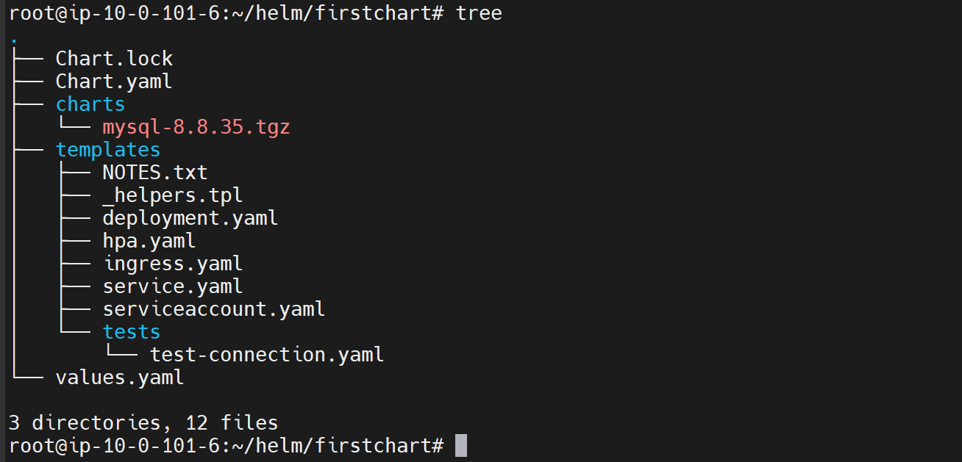

--- **note** – now charts folder have mysql. The mysql chart is successfully pulled form the central repository

**Install our app**

**# Install our firstapp**

--- helm install firstapp firstchart

**# List the pods**

--- kubectl get pods

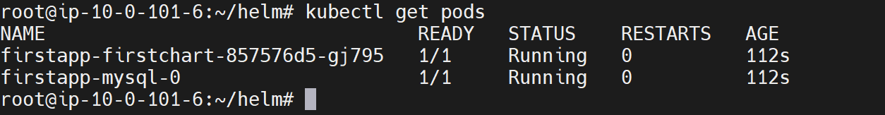

--- **note** – not only the application got created. you also see the mysql pod created that is the beauty of adding the dependencies.